Name: Mr. Herman Video Game Review
Date:___________________________

Name of the Video game: Disney Infinity
Platform: Wii, DS, Wii U, Xbox 360, PS3 Where can it be bought: All electronic stores
Cost: $74.99, Characters $12.99 Expansion packs 29.99 ESRB Rating: E- Everyone
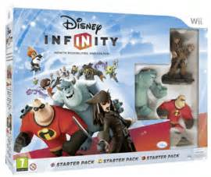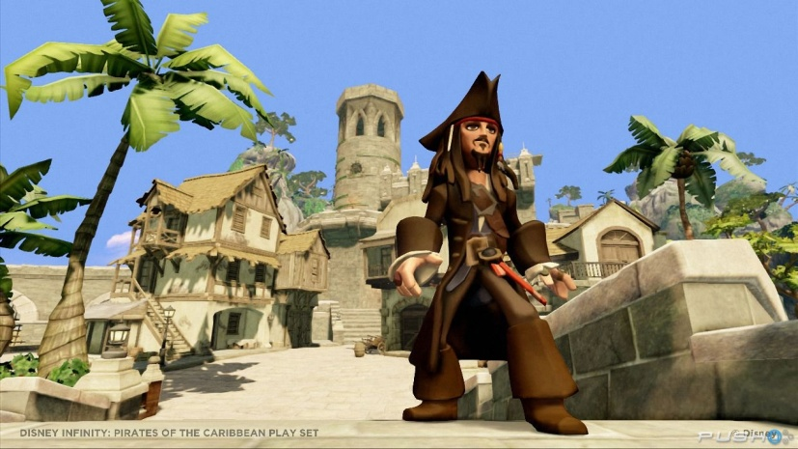

There are multiple storylines in Disney Infinity based on beloved characters from Disney. When you purchase the starter pack you receive three different storylines. The first story line is based off the character Captain Jack Sparrow from “Pirates of the Caribbean (Pirates).” In this story you travel the Caribbean Sea finding lost treasures. The storyline for “Pirates” is interesting however it does not compel you to the edge of your seat. One of the other storylines is based off of “Monsters University” in this storyline you are at Monsters University and a rival college has vandalized the campus. Your quest is to clean up the campus with different missions. This is a fun storyline that has entertaining missions and ads a spark of adventure. The other storyline included in the Disney Infinity starter pack is based off of “The Incredible.” In this story you have to battle Syndrome in his massive amount of robot army in different tasks and adventure. None of these story lines will blow you away or seem to be at all realistic but that does not mean they do not have that special spark of a Disney creation.
The true magic of “Disney Infinity” is the Toy Box mode (or in the gamer vocabulary the Sand Box mode). Here is where you get to create new worlds and adventures. However you must complete the tasks in the storylines listed above in order to get more toys that are locked in the story mode. What Disney Infinity has created is a world in which your imagination can create and build anything in the game.
The sounds of the game are not a hindrance on game play. The sound affects of the game are not meant to be realistic; they do imply the cartoonish reality of the game. However some of the characters do not sound perfectly like the voice actor that played the character in the movies. However most of the characters do sound like themselves. There are often times when a character will finally talk and the talking does not apply to what is going on in the story mode. For example when you are shooting flintlock (Captain Jack Sparrows trusty sidearm) he will often say “I didn’t see you there”. Most of the time this works well when you are shooting at a enemy, However sometimes I like to shoot at the treasure chests and that narrative of “I didn’t see you there” does not apply to a treasure chest. The voice of the narrator I find to be interesting and help the anticipation and the excitement of the game.
The game play controls on the Wii are extremely poor. It is hard to interact with some of the buttons because of the location on the controller. I would say this is the biggest problem in playing this game on the Wii. However I cannot say that this problem is solely on Disney Infinity. There is just not enough buttons on the controller to interact with a complex game like Disney Infinity. I have played this game on an Xbox 360 and found the controls to be relatively easy.
The viewpoint of the game is a 3rd person view; I typically enjoy a 3rd person view in games. However on occasion the viewpoint lags a little bit during game play, I notice there has to be input from the user (using the D pad to change the view). I find this game to be constantly fun. When you get sick of one of the aspects of the game you can get into the different storyline or enjoy fun in the Toy Box.
The graphics in Disney Infinity seem to be adequate for the game. When playing on the Wii you need a little sharper of a picture at times. However playing the game on Xbox 360 I believe the games graphics seem to be rather enjoyable. The game is not meant to blow your mind with graphics it is meant to blow your mind when it comes to the Toy Box and the expansion of the games. The graphics seem rather cartoonish however I find it very acceptable since it is a Disney game.
I would recommend this game to a friend. I believe it is a perfect game for a family. I can see Mom, Dad and children all playing this game together. If a person wants to play a good family game I think they have came to the right spot. You do not have to worry about little eyes seeing blood and gore when your character dies that character breaks apart as if it was a toy. When my wife “kills” Sully from Monsters University my son will say, “Hey Mommy you broke Sully” This can seem childish to an adolescent however it is practical for this genre of game. The great aspect of Disney Infinity is for the expansion packs.
When a family gets bored with the characters or the games they are allowed to purchase additional characters such as “Mickey Mouse”. I however would not recommend buying The Cars expansion pack. The storyline is dull and the different missions are not fun just an agitation. I believe Disney will add on to this game and add different types of expansion packs; I’m still waiting on a classic like “The Lion King.”
I’m going to give this game 9 out of 10. It is overall a fun and interactive game that combines good graphics and game play. I wouldn’t give it a 10 because of needing a particular character to enter some of the storylines and not having the storylines be multi-player was a bit of a disappointment.

