# ESSENTIAL STANDARD: 1.00: *Understand basic history of game design*

**PERFORMANCE INDICATOR: 1.01**

*Recall the general history and development of gaming, non-electronic and electronic.*

**Introduction:** The history of game development can be broken down into two categories: 1. traditional board or card games (non-electric), and 2. electric games.

**Lesson 1:**

**NON-ELECTRIC GAMES** 

The history of “non- electronic” games can be broken down into two main areas: 1. the history of board games, and 2. the history of card games.

**History of Board Games**

* 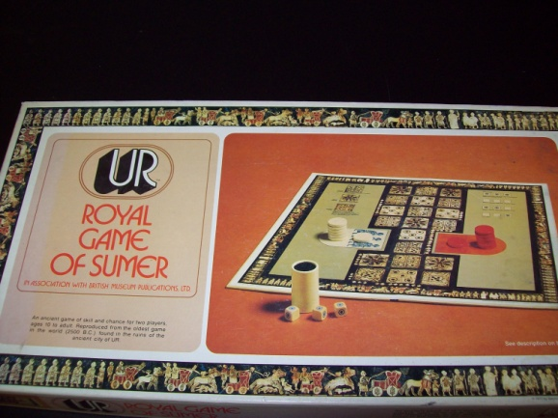One of the earliest board games is The Royal **Game of Ur** found in ancient royal tombs in Iraq dating back to 2500 BC. The ancient city of Ur was the largest city in the fertile area known as Mesopotamia, where Abraham was housed. The game consists of three rows of eight squares with two squares left out. The game is played with pyramidal dice, each one having a shaved corner to make it stand out (marked). The player would throw three dice and there could be four outcomes: one marked, two marked, three marked, or no marks. The marks represent the number of squares the player moves. Four marks also give the player another roll. There are fourteen playing pieces, seven for each player. The object of the game is to get all of your pieces off the board first. Rules found that were written in cuneiform that date back to 200 BC.

Photo by Phyllis Jones

* The **Mancala** family of games involves holes or cups where pieces rest. The object of these games is to capture the most pieces before the end of the game. The basic version of the game involves only two players. Mancala does not involve chance, but 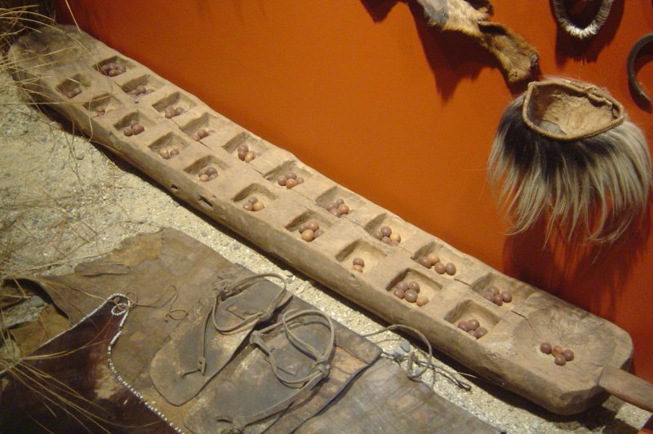mathematical skill. The players are encouraged to quickly scoop and play pieces without spending too much time calculating the best move. It is difficult to determine the age of the origin of Mancala because the materials used to make the game pieces disintegrate. The name Mancala comes from the Arabic word "naqala" meaning, "to move" and this may lead you to think the game is of Arabic origin. But, ancient copies of the game have been found in Egypt within the Cheops pyramid. The earliest versions of the game are all lost.

Reproduced with permission from http://www.aerobiologicalengineering.com/

* The ancient Chinese game of **Go** (Wei-qi

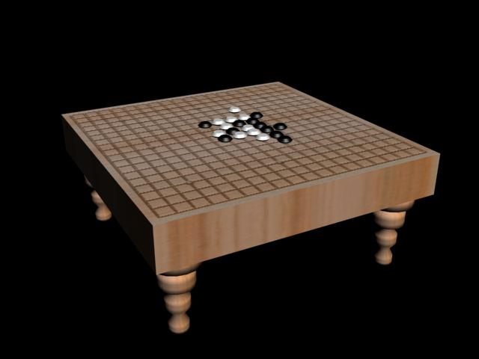"surrounding pieces" in China and I-go in Japan) was created, according to tradition, to increase the mental capacity of the ruler's sons. The game could also have been used as a divination tool with astrological references. It is believed the game dates back over 3,000 years, making it one of the most ancient board games. The game is played on a board with nineteen vertical lines and nineteen horizontal lines. Stones are placed on the intersection of lines. Each player has either black stones or white stones. The idea is to surround your opponent's pieces and capture them. It is the open areas that add to your score.

Image by Tony Meadows

* Mah Jongg is another ancient Chinese board game dating back over 4,000 years. The game may have been played on paperboards that would not have survived. Throughout most of history, Chinese aristocracy only played Mah Jongg and the rules were kept secret until the last century. The game of Mah Jongg is similar to "Rummy" and is a game for four players.
* 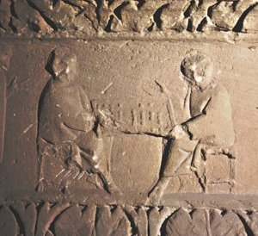The ancient Roman board game Tabula meaning "table or board". Tabula dates back to around 200 BC. Our modern game of backgammon is a form of Tabula. Tabula was popular with Roman soldiers and traveled with them on their conquests. We knowTabula reached Arabia, Iceland, Spain, England, and France. Over the centuries, many variations of Tabula have evolved. Generally, the game is classified as a race game because the object of the game is to move around the board and be the first to remove all of your pieces off the board. The different versions of the game differ in the direction each player moves, the number of dice, doubling cube, as well as some modifications of the board. All of the games have elements of luck and skill. The Roman relief shown depicts two Romans playing Tabula on a board across their knees. The organized arrangement of the chips or counters in rows indicates that this game is Tabula, as opposed to Duodecim Scriptorum, in which the chips would have been stacked. Below are game pieces and dice. Images reproduced with permission from <http://www.aerobiologicalengineering.com/>

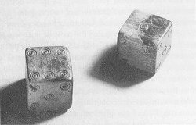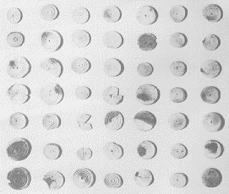

Sources: Http;//www.aerobiologicalengineering.com/.../**Roman**/.../**tabula**.html

<http://www.personal.psu.edu/wxk116/roma/tabula.html>

<http://www.astralcastle.com/games/index.htm>)

