

**History of Card games**

The earliest history of cards is believed to have originated in Central Asia. In the 10th century, the Chinese used paper like dominoes, shuffling and dealing them in new games. The oldest actual playing cards date back to the 14th century.

* The first European playing cards date from 1370 and come from Spain, Italy, Germany, and Switzerland. No cards from this time period survive. The earliest surviving cards come from around the 15th century. In those days, cards were hand-painted and only afforded by the wealthy. With the invention of woodcuts in the 14th century, Europeans began mass-producing cards. By 1500, three main suit systems had evolved, Latin (Spain, Italy, and Portuguese), Germanic (Germany and Switzerland), and French. There three suit systems became the basis of standard national patterns.

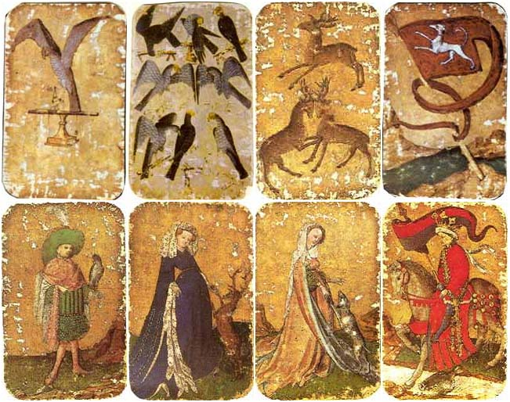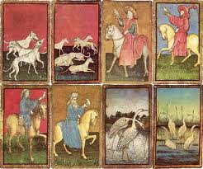

The Painted Stuttgart Pack (1430)

With permission from

http://www.wopc.co.uk/

The Ambras Court Hunting Pack (1445)

With permission from

http://www.wopc.co.uk/

* The French help design the four-suit system used today. These suits of spades, clubs, diamonds and hearts, and the use of simple shapes and flat colors helped facilitate manufacture. It was the French who were instrumental in bringing the pleasures of card play to people in Europe and the New World. French cards soon flooded the market and were exported to England first, and then in the British Colonies of America.
* Americans started producing playing cards around 1800*.* The cards were improved to include double-headed court cards (no upside down cards), varnished surfaces (durability and smoothness in shuffling), placing identifying marks on the borders or corners, and rounded corners for extended life.The joker originated around 1870 and was known as the "Best Bower," the highest card in the game of Euchre. Cards were used to advertise products and services, promote ideas, and to depict famous landmarks and events.

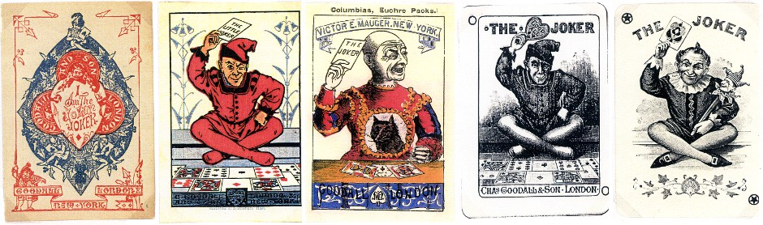

**Above**: early Jokers by the firm [Charles Goodall & Son, London](http://www.wopc.co.uk/goodall.html), (1821-1921) produced during the 1870s-1890s with permission fromhttp://www.wopc.co.uk/

* Some popular types of card game include the following.
* **Adding Games** = players play in turns, adding the value of the cards together as they are played. The goal is to reach or avoid certain point totals.
* **Fishing Games** = each player is given a hand of cards with a layout of face up cards on the table. Players play one card in turn. If the card played matches the layout card, the layout card is captured and placed in front of the player. If a card does not match, it becomes part of the layout.
* **Matching Games** = Players take turns playing cards to a discard pile. The card played must match the previous card or fit with the other card in some way (rank, suit, order). The player who cannot match or fit form their hand are penalized by having to draw one or more cards. The object is to get rid of all of your cards.
* **Card Exchange Games** = Players have a hand of cards and exchanging a card or cards with other players. The exchange may also be with a stack of face-up or facedown cards. The object is usually to collect certain cards of set of cards.
* **Draw and Discard Games** = Player have a hand of cards and two stacks on the table. The game involves picking up an unknown card from the stockpile or a known card from the discard pile. The player must then discard a card face-up on the discard pile. Players are trying to improve their position to some end goal.

Sources: http://www.wopc.co.uk/history/index.html

<http://www.usplayingcard.com/gamerules/briefhistory.html>

[www.jducoeur.org/game-hist/seaan-cardhist.html](../../Curriculum/game%20april%2008/Game%201/www.jducoeur.org/game-hist/seaan-cardhist.html)

<http://www.cs.man.ac.uk/~daf/i-p-c-s.org/faq/history_11.php>