Unit 1:Leadership Development (~3 Questions)
President- Is in charge of a typical business meeting. (#1 in charge)
Vice President- Is in charge if the President is not there. (#2 in charge)
Secretary- Who is in charge of all correspondence and paperwork for an organization (#3 in charge)
Treasurer- Who is in charge of collecting money and keeping tract of all budget items (#4 in charge)
Goals- Must be obtainable
Old business- Is not a topic that is discussed in a typical business meeting.
Unit 2: History and Impact of Sci-Vis (~10 questions)
Primitive man left behind cave paintings and hieroglyphs. As societies became more complex so did languages
MAPS- A map is a flat representation of a 3D space.
Road Maps– Show roadways and physical boundaries.
Topographic Maps– Have contour lines that show elevation
Aeronautical Maps – Have information about flight paths.
Weather Maps – Show locations of weather patterns.
Floor Plan- Shows rooms in a building.
Gene Map –Shows locations of specific genes in DNA
Concept Maps – There are several kinds of concept maps. Which are use to organize ideals
A spider map is organized by placing the central theme or unifying factor in the center of the map. Outwardly radiating
hierarchy concept map presents information in a descending order of importance. The most important information is placed on the top.
Photography- The development of photography depended on understanding the physics of light
Technological Advancements in Sci-Vis
X-ray Crystallography- When X-rays are beamed at a crystal, electrons diffract (bend) the X-rays, which causes a diffraction pattern. These patterns convert into visual maps.
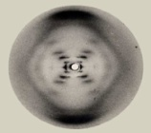
DNA- DNA Fingerprinting is a method of identification that compares fragments of DNA. DNA is the genetic material found within the cell nucleus. With the exception of identical twins, the complete DNA of each individual is unique.
Television-With the invention of television, images could be brought into the home.
Microscopy (microscopes)-
Light Microscopes use light and lenses to magnify small transparent objects. Light Microscopes are limited by the physics of light to magnify 1,000 times
The Electron Microscope was developed due to the limitations of Light Microscopes. Electron Microscopes can magnify up to 1,000,000 times.
Telescopes-
Refracting and reflecting light telescopes collect light to view distant images.
Radio telescopes collect radio waves to understand materials in space.
Orbiting telescopes eliminates problems associated with looking through the atmosphere.
Computers- allow for the manipulation of large amounts of data. Computers help automate machinery, tools, and processes. The Internet allows for rapid and widespread movement of data.
Medical Imaging
X-rays are short wavelengths that penetrate tissue producing negative images of bones.
MRI (Magnetic Resonance Imaging) is an imaging technique that uses magnets in medical settings to produce computer-enhanced images of the soft tissue inside of the human body.
Hologram- A three-dimensional image that is produced using multiple lasers
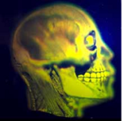
Remote Sensing
GPS (Global Positioning System) is a system able to show an exact position on the earth anytime, anywhere outside, and in any weather. The satellites transmit timed signals that can be detected by anyone with a GPS receiver.
Radar and Sonar use electromagnetic waves to determine location, position, and movement of objects.
Satellites serve a variety of purposes from transmission of television signals to guidance and tracking systems for defense.
Careers In Sci-Vis-
Medical Imaging Careers- Careers in medical imaging range from entry-level technologists through advanced scientists holding doctorates. Medical imaging involves the use of highly advanced techniques such as MRI, CAT scan, PET scan and X-rays.
Scientific Imaging Careers- These scientists use a variety of advanced equipment such as light microscopy, spectroscopy, electron microscopy, and computers to help scientists to better understand and visualize complex models and concepts
Remote Sensing Imaging Careers- Careers in remote sensing involve the science of acquiring information about the earth's surface without actually being in contact with it. Typically using satellites.
Film and Gaming Careers- Careers in the film and gaming industry require the knowledge of 3D animation, computer graphics, and computer programming. What Teenagers like
Information Visualization- Careers in informational visualization involve taking data and presenting it in a way that can better be understood. The knowledge of computer programming is essential.
Engineering and Manufacturing Careers- Engineers apply the theories and principles of science and mathematics to research and develop economical solutions to technical problems.
Industrial Design Careers- Industrial design careers originate and develop ideal to design the form of manufactured products and to consult with engineering, marketing, production, and sales representatives to establish design concepts.
Graphic Design- Graphic design is the process and art of combining text and graphics to communicate an effective message such as in the design of logos, graphics, brochures, newsletters, posters, signs, and any other type of visual communication.
Architectural Design- Careers in architectural design range from entry-level drafters through individuals holding advanced degrees in architecture (home and commercial).
Unit 3: Basic Computer Hardware and Software (~13 Questions)
*As a rule of thumb the greater the # the better it is when dealing with computer hardware and Software (if you know this concept expect approx 10 answers on the final exam!
Input Device- Input Devices: devices that input information into the computer such as a keyboard, mouse, scanner, and digital camera.
Output Device- devices that output information from the computer such as a printer and monitor.
Central Processing Unit- (CPU) also called the microprocessor, or the brain. Processor speed: The speed at which a microprocessor executes instructions. This is usually measured in megahertz (MHz)
Storage Devices:
Hard Drive- The hard-drive is a mechanical storage device typically located internally. Long term memory.
CD-ROM- (compact disk read only memory) an optical device read by a diode laser
FLASH Drive- is a compact and portable electronic storage device.
Floppy Disk- Is a compact magnetic storage device.
Computer Memory- Computer memory is binary (0 or 1) (on or off).
The byte is the standard unit of measurement.
A byte is composed of 8 bits (binary digits).
Typical units of measurement:
1 KB (kilobyte) = 1000 bytes
1 MB (megabyte) =1000 kilobytes or 1 million bytes
1 GB (gigabyte) =1000 megabytes or 1 billion bytes
RAM (random access memory)- stores data that is processing. This type of memory is erased when the computer is turned off.
GUI (Graphic User Interface) is a set of images and icons seen on the desktop used to operate a program.
Video cards- plug into the motherboard and are used to display video.
Resolution- Resolution refers to the number of pixels (picture elements) in the monitor image. Increased resolution uses more computer resources but increases the visual clarity of the display.
Networks-
LAN: are networks usually in the same company or building. The Local Area Network is connected via telephone lines or radio waves. Most LANs connect workstations.
WAN: are systems of LANs that are connected. (Wide-area network)
Multitasking- is the ability to execute more than one task (program) at the same time. Only one CPU is used but switches from one program to another.
Multiprocessing- more than one CPU is used to complete a task. Example: network rendering.
File Management- Different programs have different file extensions.Naming files - avoid the following characters in naming files:
Examples: @, *, .
Understand the parts of a path name. Example: C:\SciVis\movie.avi
Drive designator Directory or folder File name File extension
Basic Computer Software: Software is the general term for information that's recorded onto some kind of medium. Example Computer Programs.
Spreadsheet: Allows the user to collect and manipulate data onto a spreadsheet. Data may then be graphed.
Word Processing- Allows the user to create and print word documents.
Drawing Software- Allows the user to create technical and artistic drawings. Example Adobe Illustrator
Animation and 3D Modeling Software- Allows the user to create 3D static models and/or animated movies. Example 3d Studio Max
Presentation Software- Allows the user to put together dynamic and visual computer presentations. This is usually in the form of a slide show. Example PowerPoint
Web Editor Software- Allows the user to create html documents for use on the Internet. Example Notepad, Dreamweaver
Photo Editing Software- Modifies rasterized images. Example Adobe Photoshop
Video Editing Software- Allows the user to edit video clips. Example Movie Maker

The Ethical Use of Electronic Media.
Copyright- is a form of protection provided by the laws of the United States (title 17, U.S. Code) to the authors of “original works of authorship,” including literary, dramatic, musical, artistic, and certain other intellectual works.
Plagiarism- includes a range of actions from failure to properly cite works to wholesale cheating. A student who plagiarizes may do so unintentionally or with purposeful deliberation. Listed below are some common forms of plagiarism.
Trademarks- are familiar names and symbols that have become associated with quality, reliability, and/or fame. That’s why people and companies spend millions of dollars protecting these images.
Fair use - acceptable limits to which a person may use copyrighted material without the owner’s permission.
Music - 10% or 30 seconds –whichever is less.
Video - 10% or 3 minutes - whichever is less.
Be aware of the condition “whichever is less.” In order to use 30 seconds of a song, your song must be 5 minutes in length and most popular songs are only 3 to 3 ½ minutes.
Unit 4: Design Fundamentals- (30 Questions)
Balance- is the optical illusion of equal spacing of objects.
Formal Balance- is symmetrical. These layouts often convey a sense of tranquility, familiarity, elegance or serious thought.
Informal balance is asymmetrical. Involves several smaller items on one side are balanced by a large item on the other side
Rhythm -is a reoccurring movement or pattern
Proportion- is the relative size of one object in comparison to another.
Emphasis- is the method used to draw attention to a part of the design by making it the focal point or the main idea.
Unity- Repeating all aspects of the design (repetition) is the completeness and harmony of a design.
Shape is any form that occupies and defines negative and positive space. Shape is anything that has width, shape or depth. There are three types of shapes:
Geometric- (triangles, squares, circles)
Natural- (animals, plants, human)
Abstract- (simplified versions of natural shapes)
Texture- is the look or feel or any object or surface.

Picture window Type Specimen Copy heavy
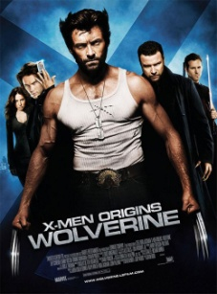
Mondrian Omnibus (circus Multi-panel Silhouette
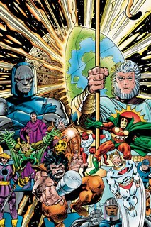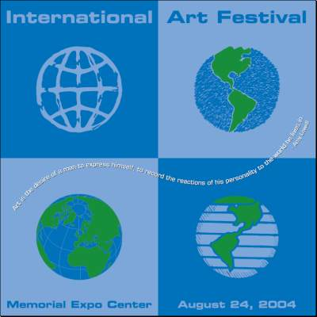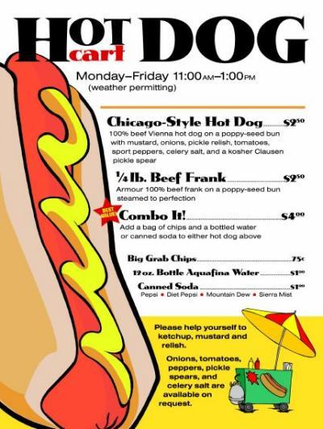
Power Point Techniques-
Backgrounds Only use one per presentation.
Use the 6,6,6 rule (as a rule of thumb) *no more than 6 lines *6 bullets *6 words in a sentence
Type Keep it consistent. Use at most two fonts per presentation. Use bold type to improve readability. Use big type. Body text 20-22 points. Subtitles 24-28 points. Headlines 36 or more
Color- Light waves (wavelength) produce a range of visible energy that forms all the colors the human eye can see by adding/mixing the three primary colors of light: Red, green and blue (RGB).
Light Color- (additive) - 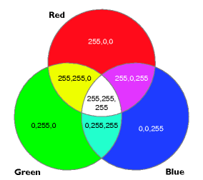 Color from the light model is brighter and has a wider spectrum (gamma range) than that of CMYK (cyan, magenta, yellow, black).
  - RGB Primary
  - CYMK Secondary
  - RGB+CMYK=White
  - Examples: TV, Computer Monitors, Projectors,
Pigment-(subtractive) 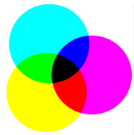 Pigments are produced when certain wavelengths of light are absorbed and others are reflected or transmitted
    - CMYK- Primary
    - RGB-Secondary
    - CMYK+RGB=Black
    - Examples: clothes, magazines, books, paintings
Hue- When you change the Hue you change the color.
Satuation- When you change satuation you add more white to the color more it looks washed out
Value- When you change the value the more gray it is
Complementary Colors- Colors Across from eachother on a color wheel
Analogous- An example of an analogous (colors adjacent to each other
Humans are restricted by the limitations of their eyes and ears to perceive the world Our eyes have cells, contained on the retina, that chemically respond to the different wavelengths of light.

Vector vs. Bitmap
Vector images- (also called outline images) are images made with lines, text, and shapes.
Advantages-
*Vector graphics are resolution independent, which means they can be output to the highest quality at any scale.
*Vector graphic images normally have much smaller file sizes than raster-based bitmaps.
*Changing or transforming the characteristics of a vector object does not effect or distort the object.
*Vector images are not limited to rectangular shapes like bitmaps.
*There is no background unless it is placed behind the image as a layer
Bitmap images- (also called RASTER images) are made with pixels (picture element), which look like rectangles.
Advantages-
Bitmap images produce larger files sizes.
Bitmap images have restrictions in regards to alterations and modifications such as scale, image distortion, and format conversion.
There is a common appearance of blocked or jagged edges and blurriness in the image, which must be compensated for with sharpness filters.

Unit 4: Interpreting Data for use in Charts and Graphs (~15Questions)
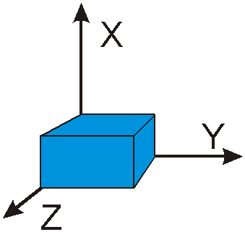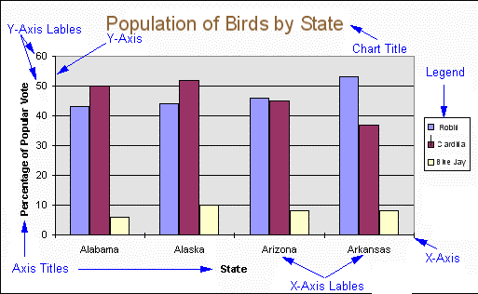
Z
X
Y
- Qualitative data – includes information that can be obtained that is not numerical in nature.
- Quantitative data – includes information that can be obtained that is numerical in nature.
- Independent variable – is the variable that you believe might influence your outcome measure. It is the variable that you control.
- Dependent variable – is the variable that is influenced or modified by some treatment or exposure (the independent variable).
Bar Chart- Used for comparing items that are not related to each other-also comparisons between unrelated variables.
Bar graphs are a family of charts that display quantitative information
Stacked Column Chart- A type of bar chart, the stacked column chart, shows several sets of related data adding up to a whole with their columns stacked on top of each other.
Line (X-Y) Graph- Used for related variables and relationships over time.
Pie Chart- Used for showing parts of a whole or percentages.
Scatter Plot Graph- Used to get a visual representation of the relationship or correlation between two variables using the x-y graph method of plotting.
Histograms- Histograms are bar charts that display frequencies or relative frequencies in the form of contiguous (touching) bars.
File Formats: Every time you create a document or a graphic on a computer, the item is saved with a particular file format. Example: Yourname.doc has a .doc file
3Ds Max = .3ds Photoshop = .psd MS Excel = .xls Adobe Illustrator= .AI
Image File Formats
TIFF- (Tagged Image File Format)-TIFF is the best format for files that must go cross-platform such as from a Windows system to a Macintosh computer.
JPEG- (Joint Photographic Experts Group) JPEG is actually a compression algorithm for static images, not a file format.
GIF- (Graphical Interchange Format) GIF's are compressed graphic images that are platform independent for use in any computer. It is a lossless format that uses LZW compression. It compresses at a ratio between 3:1 and 5:1
BMP- (bitmap) BMP files are used for bitmap images within the windows operating systems. Most often used for certain screen backgrounds for Windows operating system.
AVI- (Audio Visual Interleaved) AVI’s are sound and motion picture files that were developed by Microsoft for storing audio and video data.
File Compression- There are two types of file compression, lossy and lossless.
Lossless compression reduces the size of the image but results in an image that looks exactly the same as the original. LZW (Lempel, Ziv, and Welch) is a popular lossless compression algorithm.
Lossy compression results in a loss of data, and in turn, a loss of image quality. A picture saved with lossy compression may not look as good as the original image.
Steps to A Design Brief:
I.D.E.A.L. Problem Solving Process –
I – Identify the problem
D – Define the plan of work
E – Explore the problem through research
A – Act on the problem’s possible solution
L – Look back at the process
S.A.F.E. Design Process
S – Simple
A – Appropriate
F – Functional.
E – Economical
Unit 6: 3D modeling Static and Dynamic Viusalization (~20 Questions)
Basic Modeling- basic primitives: Sphere, Cube or box, Cylinder, Torus, Cone, Plane, Chamfer box (rounded corners of a box)
2D Shapes- Arcs, ellipses, circles, curves, and freehand curves are basic 2D shapes typically provided within modeling programs. Shapes may be combined to create complex objects.
Extruding- Creating a 3d shape by using a 2d shape and giving it a thickness.
Modeling Techniques-
Boolean tools or operations are used to create objects by combining, subtracting, or determining the common intersections of various objects such as primitives.
Union or Addition (+ or ∪) is used to combine objects together into one new object.
Subtract or Difference (−) is used to remove part or all of an object where objects overlay each other.
Intersection (* or ∩) is used to calculate the overlapping volumes of objects so that the overlap becomes the object.
Extrusion, sweeping, or lofting allows you to create a 2D shape and then extend it along a path or curve to form a 3D object.
Lofting- A variation of sweeping is lofting, where a series of curves (open or closed) is lofted or spaced parallel to each other, and then a surface is generated that connects the contours.
Revolve or lathe operations allow the user to create a 2D shape and then revolve it around an axis.
Transformations or Transforms are actions that scale, rotate, and move objects
Scale changes the size or proportions of an object along one or more axes.
Non-uniform Scale- Change the shape by scaling one direction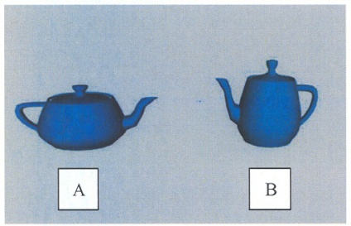
Uniform Scale- keeping the same shape by scaling all sides results in changing the size only.
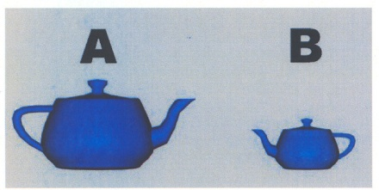
Rotate refers to tilting or changing the direction that an object is facing.
Deformations are used to modify an existing shape.
Copy or Clone tools allow selected objects to be reproduced in their exact size and form.
Viewing Tools-
Wireframe - draws objects as edges and vertices.
Solid mode - allows the object to appear as a solid.
Zoom – controls the amount of magnification of the active viewport.
Rotate – allows objects to remain in their correct, relative positions within the scene while you rotate your point of view around them.
Panning (Eye Move) – allows you to drag the scene vertically and horizontally within the viewport (window), changing your viewing point but not changing the positions of the objects within the scene or your viewing angle.
Rendering Format- Rendering produces a finished image.
Texture- in 3D computer graphics refers to image patterns rather than the “feel” of materials. Surfaces may have single colors or they may have multiple color patterns, which are commonly referred to as textures.
Surfaces may have single colors or they may have multiple color patterns, which are commonly referred to as textures.
Opacity maps control whether a material is opaque, transparent, or translucent.
UVW mapping is a way of trying to solve the distortion problems that occur when applying image maps (textures) to complex surfaces.
U represents the horizontal component of an image. It corresponds to the X axis dimension in 2D coordinate space.
V represents the vertical component of an image. It corresponds to the Y axis dimension In 2D coordinate space.
W represents the z axis in 3D coordinate space.
Bump maps simulate the roughness of surfaces even though the surfaces are perfectly flat. Bump maps make an object appear to have a bumpy or irregular surface. This is possible because of higher areas are light and lower areas are dark.
Lighting- 3D programs have some type of default lighting, which can be changed to create a more realistic appearance.
Animation-is created when still images are played in rapid succession so that they appear to produce images that are constantly moving.
Animation appears to have continuous motion because the human eye (brain) “holds-onto” the still image for just a brief moment after it is viewed, and the image is still “there” (in your brain) when the next image is viewed. DYNAMIC.
Early Animation- A master artist would draw the most important or key frames (“keyframes”), and less-skilled or less-experienced artists would fill in the action for the in-between (“tweens”) frames. Other artists would paint or fill the outlines with color.
The Walt Disney Studios developed animation into a modern art during the 1930s and 1940s.
Computer Animation- Unlike early animation, where every frame must be created to produce movement, in computer animation you define points in time (known as keyframes) and the computer draws all of the in-between frames.
Storyboarding- A storyboard is a graphic, sequential depiction of an animation that is going to be created. It is a visual script designed to make it easier to see the animation scenes before they are created.
The National Television Standards Committee (NTSC) frame rate = 30 frames per second for television (North America and Japan).
PAL (Phase Alternate Line) is the European standard of 25 frames per second.
The standard rate for film (motion pictures) = 24 frames per second.
Calculating Frame Rate A frame rate of 30 fps will require 1800 images for one minute of animation (30 fps x 60s).
Zoetrope was a device that was used to produce animation in the 1800s.
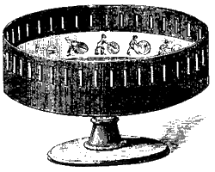
EXTRA 3ds Max:
Merge- Bringing in a new file to an existing file in 3d Studio Max
Group an object – Grouping an object prevents the object from being named the same thing in an object.
Saving an image- To merge an image to 3ds max you must be converted into a Bitmap
F9- Quick key to access Rendering
Digital Image Formats
Every time you create a document or a graphic on a computer, the item is saved with a particular file format. Example: Yourname.doc has a .doc file format, which identifies it a MS word file.
Examples:
3Ds Max = .3ds, .max
Photoshop = .psd
MS Excel = .xls
Corel Draw = .cdr
Word=.doc
PowerPoint= .ppt
File Compression- Compressed files are files that have been altered to produce a smaller file size ( uses less memory).
Algorithms are programs that are written into software for file compression.
There are two types of file compression, lossy and lossless.
Lossy compression- a loss of data, and in turn, a loss of image quality by removing bits of color
Lossless compression reduces the size of the image but results in an image that looks exactly the same as the original. Example LZW Algorithm
Image File Formats
TIFF (Tagged Image File Format) can be use cross-platform from Windows system to a Macintosh. Tiff are high quality because they are a Lossless LZW compression, therefore it is accepted for use in professional printing applications.
JPEG (Joint Photographic Experts Group) JPEG is actually a compression algorithm for static images, not a file format. JPEG’s are popular for photographs, artistic, and other complex images because they permit you to have 24 bit (16.7 million) color. The JPEG compression algorithm produces lossy compression.
GIF (Graphical Interchange Format) GIF's are compressed graphic images that are platform independent for use in any computer. Gifs are typically cartoon or clip art images and are a Lossless LZW compression. Gif also support transparent images.
BMP (bitmap) BMP files are used for bitmap images within the windows operating systems. Most often used for certain screen backgrounds for Windows operating system. Can be compressed and other controls applied, but it is seldom used by third party software.
AVI (Audio Visual Interleaved)-AVI’s are sound and motion picture files that were developed by Microsoft for storing audio and video data.

