ELECTRIC GAMES
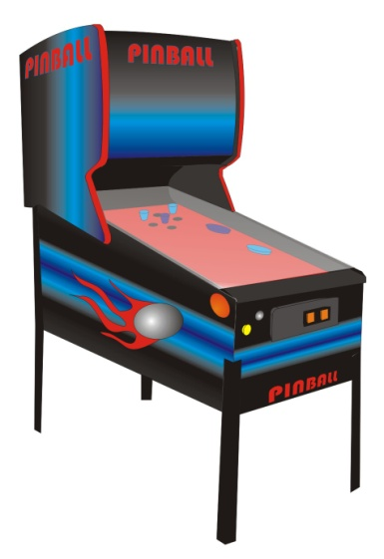
Two distinct game paths developed in the 1950’s.
- The first path started in 1951 when Marty Bromley launched SEGA (Service Games). Mr. Bromley was a game facility manager on a military base. This development launched the coin-operated games of the 1970s called video games. These games later developed into the console games of today.
- The second path segment started in colleges and universities. College programmers developed games to practice acquired skills and entertain themselves during breaks. Their efforts lead to the mainframe games that came on the market with the personal computer revolution. In 1952, Dr. AS Douglas at the University of Cambridge created the first graphical computer game. It was a simple version of tic-tac-toe. These types of games are known as computer games.
Image by Duncan Grant

Video Games/Arcade Games
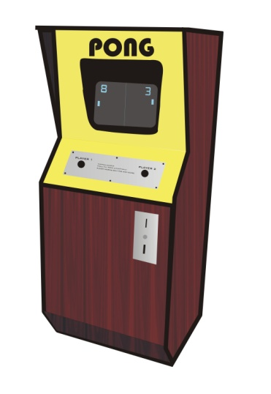
Early arcade games consisted of games like pinball located in small amusement parks. In 1958, William Higginbotham, the head of Brookhaven National Laboratories, created a game like tennis to entertain visitors. As these games became more popular, they slowly became more accessible to the public. Locations were closer to schools and local neighborhoods. These arcade halls became a very popular hangout area for teens. Milestone games of this era include the following.
- Pong: 1972 by Atari. Nolan Bushnell and Alan Alcorn designed Pong. Pong was the first successful arcade video game as well as the first coin-op arcade game. The game play was extremely simple. Two players, each controlled a vertical bar on opposite sides of the screen. The bar would bounce back a moving dot between the two vertical bars. The loser was the player to miss hitting the moving dot. Nolan placed the first game machine in a local gas station, after a few hours when he returned, the machine was no longer working. The game was full of money. Pong became an instant success and was responsible for creating the arcade video game industry.
Image by Grayson Beaman
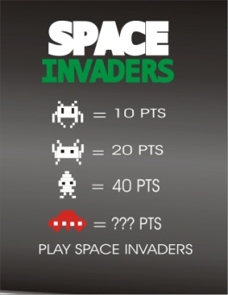
- Space Invaders: 1978 by Taito/Bally/Midway. Space Invaders became the first blockbuster videogame. It was credited with bringing video games out of arcades and bars and into nicer restaurants, corner stores and into the public consciousness. Space Invaders was later translated to Atari 2600 video home game system and became a huge commercial success.
Image by Adam Gay
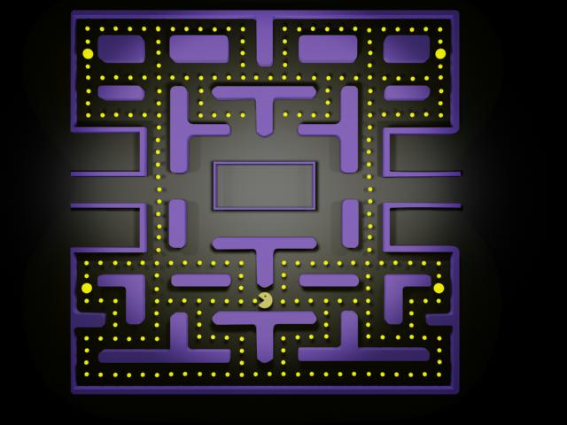
- Asteroids: 1979 by Atari. This game was designed by Ed Logg and utilized a monochrome vector graphics display. This type of display used fast moving objects made of very sharp lines. It was quite a contrast to the crude pixel graphics of other games during the same period. The new graphics combined with great game play make it the biggest selling game of its time.
- Pac-Man: 1980, by Namco. Pac-Man appealed to a larger market without the shooter aspect of previous successful games. Over 300,000 units were sold making Pac-man the most popular game in arcade history. Pac-man launched the idea of levels in later spin offs of the game. Ms. Pac man used plot structure animated sequences, along with pastel colors. These added features made the game appealing to girls and families thus widening the game market. To date, Pac-Man has spawned more game sequels than any other video game.
Image by Luke Hancock
- Donkey Kong: 1981 by Nintendo. This game’s storyline was a cross between King Kong and Beauty and the Beast. The main character, Mario, attempts to rescue his girlfriend from a beast. Mario became one of the most famous and successful game-character ever invented.
- Centipede: 1981 by Atari. This game was co-designed by a woman. The game used a unique pastel color scheme, which made it very popular with women as well as men. In 1981, the US arcade business was at its peak. Revenues reached $5 billion dollars while Americans spent over 75,000 hours playing video games.
- Pole position: 1982 by Namco. Pole position became the first successful driving simulation game.
- Tron: 1982 by Alley Midway. Tron was the first game to be licensed and commissioned by a film studio.

Video Games/Console and Handheld Games
      - Magnavox Odyssey: 1972. Odyssey was the first home console game released in 1972. It was not widely accepted and was basically ahead of its time technologically.
      - Atari: 1976. Atari reached success with the release of its inexpensive 2600 system in 1976. This marked the beginning of the home console market. Atari made more money from the games used on the system rather than from the system. Popular Atari games include Adventure, Yar’s Revenge and Space Invaders (1980). Atari games were the first to have an Easter egg or hidden message. The developer hid his name in many places in the game. The player could stumble on the name or hidden message. This system uses a joystick and is played on a regular TV.
      - Mattel: 1977. Mattel released two handheld games in 1977. Each handheld only played one game. They were very expensive. Other game titles were released such as Auto Race, Basketball, Bowling, Football, and Sub Chase.
      - Mattel Intellivision: 1978. Intellivision was more expensive than other games of the time. The joystick was replaced with a controller type keypad and a movement disc. In 1984 Mattel was shut down due to heavy financial losses.
      - ColecoVision: 1982. ColecoVision was released by Coleco and became the standard for home consoles. The controller used a mushroom like joystick and the game displayed superb graphics. The console came with Donkey Kong and played other favorites including Venture, Mr. Dot, Lady Bug, and Space Fury. Coleco in the 70’s and 80’s also released some of the most successful mini arcade tabletop games including Frogger, Zaxxon, and Galaxian. But the glory days of home consoles were numbered. In the 1980’s the home console industry experienced a slump. The sump was a result of three basic facts: 1. too many console choices for the consumer: 2. many of the game were not enjoyable and many were related to the movie ET; and 3. consumers were looking at computers now instead of consoles.
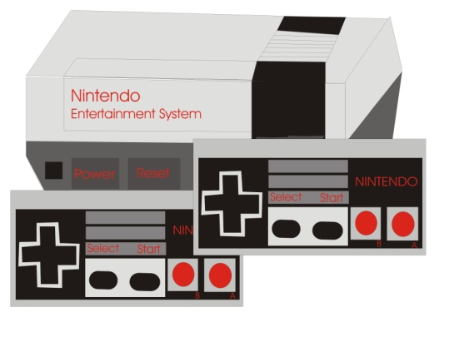
      - Nintendo: 1985. Nintendo helped revive this slump by releasing a popular console in 1985. The console was so popular it is credited with closing the door on the video arcade business. The system was very advanced graphically and included interesting storylines like Super Mario Brothers, The Legend of Zelda and PunchOut. The NES system sold over 50 million systems. In 1989Super NES was released helping place the game Super Mario Brothers as the most successful non-bundled game cartridge in history. During the same time period, Nintendo acquired the rights to another game, Tetris, and released it. There was an ensuing court battle as to the ownership of Tetris. Today Tetris is a registered trademark of the Tetris Company, LLC.
Image by Jordan Clark
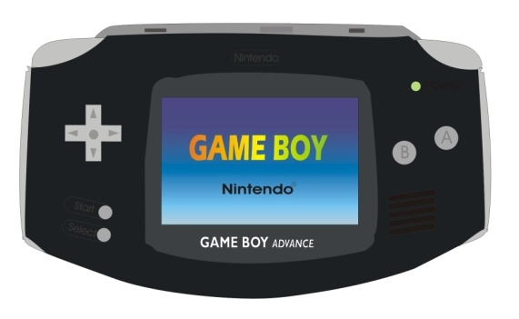
      - Game Genie: 1991 by Galoob toys. The unique system allowed players to cheat on NES games and thus win more easily. Nintendo tried to block the sales of the Game Genie.
      - Game Boy: 1995 by Nintendo. Nintendo forever changed the handheld industry when the Game Boy was released. Tetris was the main game for the monochrome version. The color Game Boy Advance version followed in 2000. The Game Boy also helped bring cartoon themes into the game industry.
Image by Perry Setzer
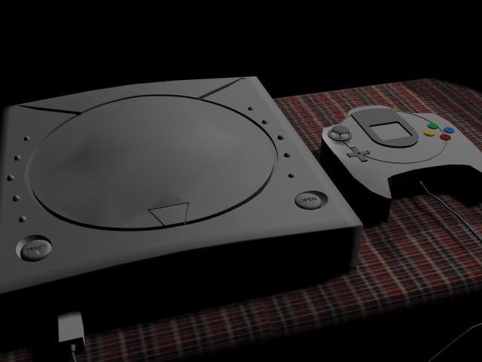
      - Sega Master System: 1991. Sega Master System was released in 1991 including the popular game Sonic the Hedgehog. The character was so successful it later became the mascot for Sega. In 1992 Sega Genesis outsold Nintendo and took control of the market. Sega later released seven different platforms including Saturn, Genesis, Game Gear, Pico, Sega CD, 32X, and 32Xcd, all which were non-compatible.
Sega also released the Dreamcast (image) in 1998. It was a short lived release and the console was noted as being ahead of it time technologically.
Image by Luke Hancock
      - Play Station: 1995 by Sony. With the release of the Play Station, Sony secured the number one spot. Nintendo’s N64 gave some competition. These games are 23-bit and 64-bit game systems.
      - “X” Box: 2001 by Microsoft. The “X” Box was Microsoft’s first product that ventured into the video game console market. The X Box has a unique feature that allows up to four players to play at the same time. The game could also allow other systems to link together for a grand total of 32 players playing at the same time. The X-box 360 was released in 2007.
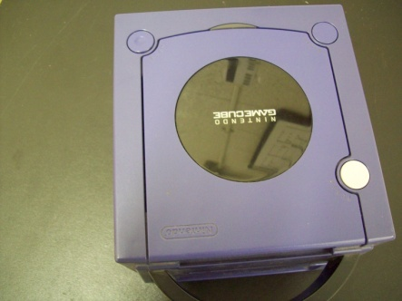
      - Nintendo’s GameCube: 2002. Wii: 2006. The Game Cube system is the most compact and least expensive of the systems during the early 2000’s. The Wii system features wireless controllers, which could also be used as a handheld pointing device. It can detect acceleration in three dimensions. The Wii outsold all of its competition combined.
Photo by Phyllis Jones

The Personal Computer Game
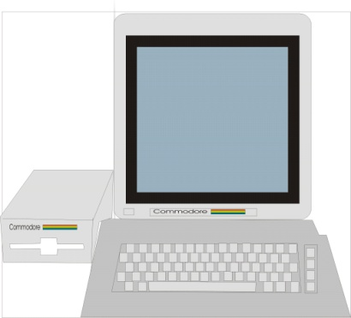
With the popularity of home computers, games could be played on the computer in addition to the home console. Several computer systems such as the Apple II and the Commodore 64 were developed with games in mind. Listed below are some of the games used on the PC.
- Colossal Cave: 1976. - Later expanded to Zork in 1979. The game used two word commands such as “go west” or “get inventory”.
- Mac-Hach-6: 1966 This game was the first computerized chess game.
Image by Dominic Foster
- Conway’s Life: 1970 this game allowed the player to set the rules for life forms as they evolved.
- Trek: 1971 Trek was followed with the Star Wars craze games.
- Utima’s Origin: 1979. This game had adventure and role-playing with many sequels.

