Name: _____________________________ Date:______________________
Current Event: The Division = Ebola?

“The only difference between reality and fiction is that fiction needs to be credible.”
― Mark Twain
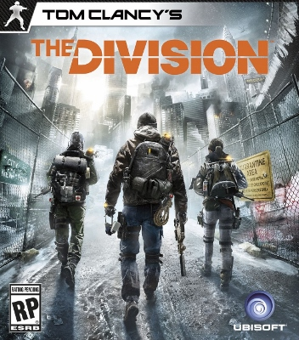
Last spring (Spring 2013) my students showed me “The Division” a Tom Clancy game created by Ubi Soft. A game based off Marshall Law that all started from a disease. Since watching the trailers and until now I have been looking at “The Division” and have been asking myself could this possibly happen…..
http://www.youtube.com/watch?v=kOHYS2BBKY8
http://en.wikipedia.org/wiki/Tom_Clancy%27s_The_Division – Wikipedia is generally not a good source but since this game is still in a developing stage we will allow it.
http://news.softpedia.com/news/The-Division-Has-Dynamic-Story-Thousands-of-Hours-of-Gameplay-363582.shtmlv
You may need to research a little more on your own…
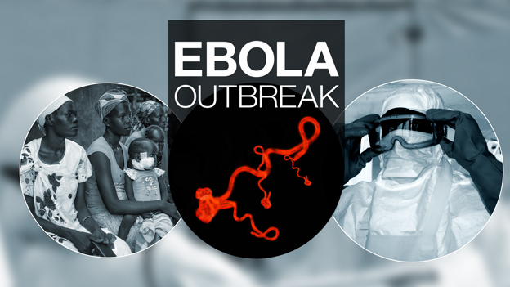
Fast forward to today Fall 2014. Now we have an Ebola potential outbreak, a Virus that has a 90% fatality rate. We have our fist diagnose case in Texas with absolutely no cure. A disease that can be passed very quickly without even noticed. How does this disease transform from patient to patient? How can we as Americans protect ourselves from people who have Ebola? Could the Ebola Outbreak crush our Economy and our civil services causing Marshal Law?
http://www.webmd.com/a-to-z-guides/ebola-fever-virus-infection
http://www.cdc.gov/vhf/ebola/outbreaks/2014-west-africa/united-states-imported-case.html
You may need to research a little more on your own…

Essay: write a 2-3 page paper discussing:
Paragraph 1: Introduction to the paper briefly discuss both “The Division” and Ebola
Paragraph 2: Go into detail about “The Division” Explain the Storyline in details. I do not care about game play just storyline.
Paragraph 3: Why do you think the story line of “The Division” is so interesting? Explain Black Friday and how a disease can be spread through currency?
Paragraph 4: What happens to the Government and our infrastructure in “The Division?”
Paragraph 5: What is the Ebola Virus? Give brief overview of the disease, where did it start?
Paragraph 6: How do you think the Ebola Disease will spread? Could it spread on currency, hospitals, Schools, malls, career fields, military?
Paragraph 7: What has the government done to stop Ebola? What will/could the repercussions be?
Paragraph 8: The one thing we do not know is how “The Division” or Ebola will end… Here is where I want you to write a storyline of how you think both the Division and Ebola will end. How would you stop the spread of Ebola? What would you do if there was a collapse of the Government like “The Division” because of an epidemic?

