Activity 1.13
Own Card Game
COMPETENCY: V101.
Understand basic history of game design

OBJECTIVE: V101.01
Recall the general history and development of gaming, non-electronic and electronic.

Introduction: Card games come in many varieties, shapes and sizes. From the history we can see some popular examples. Most card games involve some basic elements such as discarding, card exchanging, and matching to name a few. Let’s see how creative you are by using on or more of these elements to create your own card game.

Materials:
Internet, 2D drawing package, printer, and game evaluations sheet.

Lesson:

- Work in groups of 2. Study the play patterns from the curriculum (matching, discarding, and so forth)
- You and your partner should create a simple original cards games using one or more of these play patterns. Be creative. Remember cards can be anything. Research online for some ideas. (see examples)
- Sketch your idea and obtain approval from your teacher.
- Write the rules for your game in a word document. Research online for the basic rules format and content.
- Create the cards in a 2D drawing package.
- Play-test your game and revise the rules as needed. Print the rules when satisfied.
- Exchange games with your classmates and evaluate the games.

Card Game Examples:
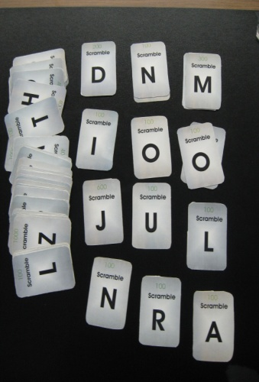
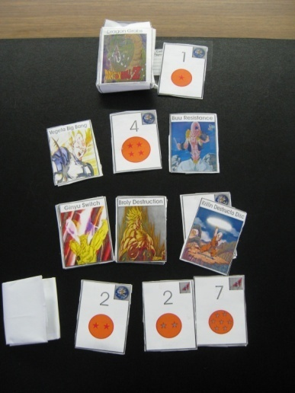
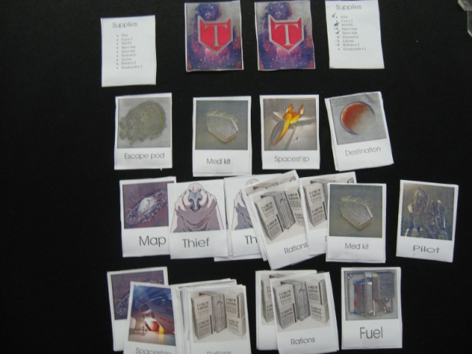
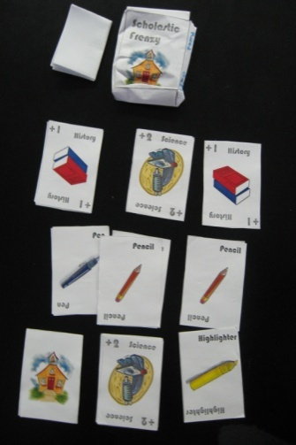
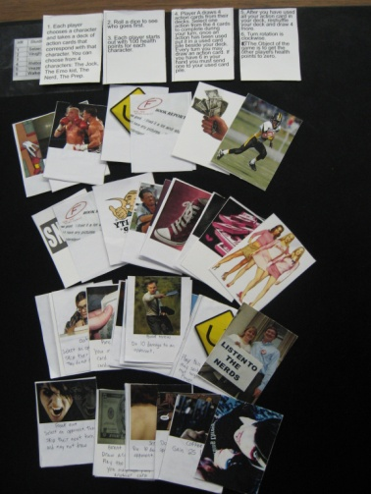
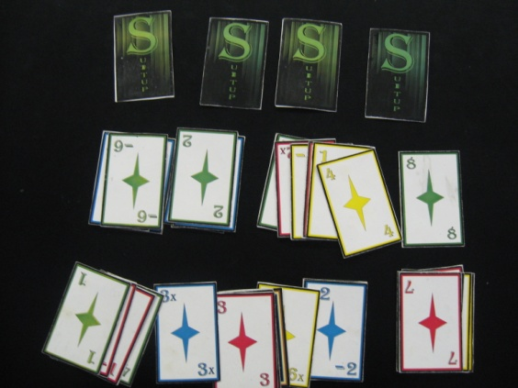
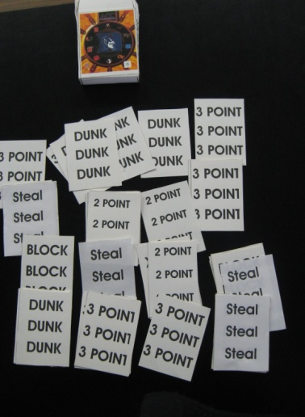
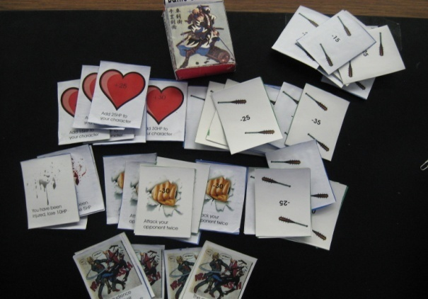
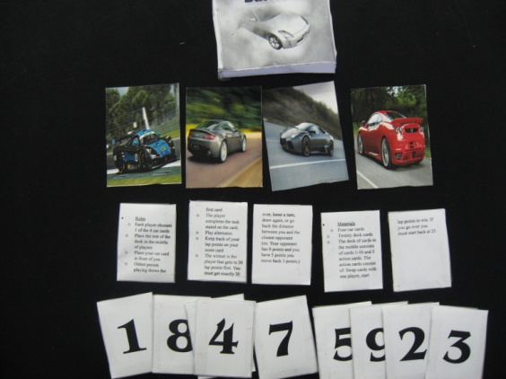

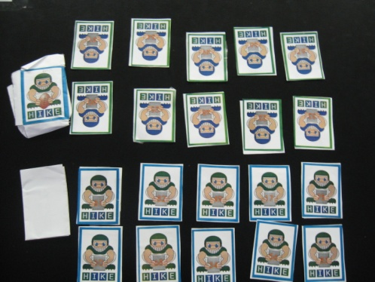
Card Game Rubric

 | Beginning  1 | Developing  2 | Accomplished  3 | Exemplary  4 | Score
Game creativity and originality | The game is a collection or remix of existing card games. There is no evidence of original thought. | The game may have a new twist or a small addition to an existing game. There is little evidence of new thought or originality. | The game shows some evidence of originality. The game may be based on an existing idea, but extends beyond to offer new insights. | The game shows significant evidence of originality. The games content is new, original, and inventive.
Game rules document | The game document is nonexistent, full or errors (more than 10), or does not work to help explain the rules of the game. | The game document has some grammatical errors (8-10), and is missing more than 3 key steps to play the game | The game document has some grammatical errors (5-8), and is missing 2 key steps to play the game | The game document has few grammatical errors (less than 5), and is missing no more than 1 step to play the game
Card graphics | The graphics and are unrelated to the game idea and do not enhance game play or are distracting decorations that detract from the game. | Some of the graphics are unrelated to the topic/theme but do not affect game play. | The graphics relate to the game but are basic and uninteresting. | The graphics assist in presenting an overall theme that appeals to the audience and enhances the play of the game.
Game playability | The game makes no sense and in unplayable. | The game is somewhat playable but has major flow problems. The game cannot be completed. | The game is playable, but not interesting. | The game is playable, fun and enjoyable.

