Activity 5.21 Game Levels and Character

OBJECTIVE: V105.04
Produce two related game levels and a 3D character

Introduction: Video games usually involve a basic scene or setting for the story. The scene needs to set the mood or tell part of the story of the game. Lighting, camera position, and materials, textures, and environmental effects all play a part.

Materials:
- 3D modeling package
- A Image with a material found on the internet with the building you will create.

Lesson:
Level 1:
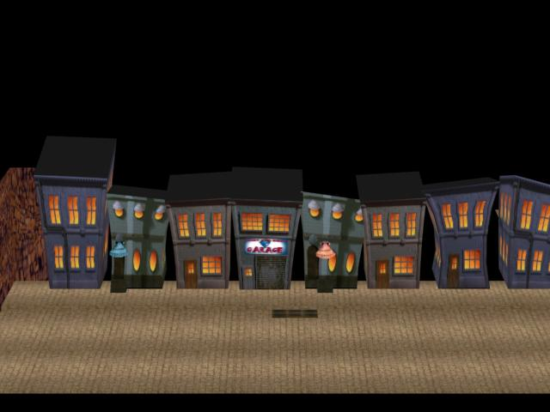
- You will create a level scene for a game. The scene will be on a cartoon type city street or town at night. All building will be original. You will create one building with Mr. Herman as a class as well as your own building you want to put in your city.

Images by Vincent Mazzo
- Then create an original building to your city in a new Max window. Examples of ideas are below. Each student should select a different building. Save your new building and share with the other students who can merge all of the building into their toon towns.
Examples:
Church, school, grave yard, basketball court, park, Chinese restaurant, Bridge and river, Capital Building, Hospital, Fast food restaurant, Hotel, Sports Arena, football stadium, baseball field, flower shop, child care, Theater, Police station, Fire Department, Gas station, Car dealer, farm, Acme building, Fair, other ideas you have. (see examples)
- Other items can be added to increase realism. The goal is to produce a realistic looking city/town street.

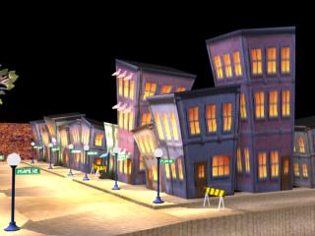

Images by Vincent Mazzo

Original Character. Now we need a character to run through our game.
- Create an original character for your levels.
- Place your character in the scene.
Extension:
Rig the character and have them move in the levels.

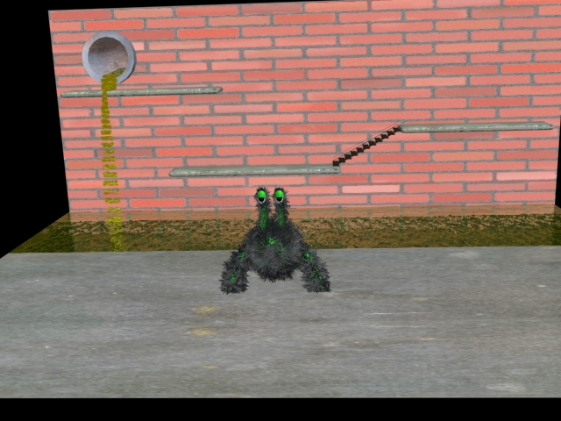

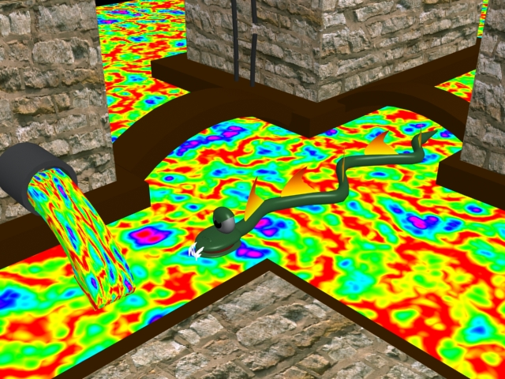
Student Images

Game Levels Rubric

 | Beginning  1 | Developing  2 | Accomplished  3 | Exemplary  4 | Score
3D models/ Visual Appearance | 3D models do not follow  graphic design composition  rules. Proportions, balance  and/or use of color are not correct and inappropriate for the level. | 3D models show basic design  qualities. Proportions,  balance, and/or color usage  are lacking and have trouble fitting into the level setting. | All 3D models show good design  qualities including 3D,  balance, and texture/color  usage and somewhat fit into the game setting. | All 3D models show excellent  design qualities including  proportion, balance, and  color/texture usage and fit into the level correctly.
Level I creation Toon Town | The game level contains few if any of the necessary elements, is not proportional, and not aesthetically pleasing. | The game level contains some of the necessary elements, is partly proportional, and not very aesthetically pleasing. | The game level contains most of the necessary elements, is mostly proportional, and is somewhat aesthetically pleasing. | The game level contains all of the necessary elements, is proportional, and is aesthetically pleasing.
Level II creation Sewer | The game level is a copy of another example or not a sewer, is not proportional, and not aesthetically pleasing. | The game level is not very creative, is partly proportional, and not very aesthetically pleasing. | The game level is somewhat creative, is mostly proportional, and is somewhat aesthetically pleasing. | The game level is highly creative, is proportional, and is aesthetically pleasing.
Character | 3D character is missing or very primitive, demonstrates  poor skill in modeling and texturing, and is not appropriate for the game levels | 3D character is not very creative, demonstrates  basic skill in modeling and texturing, and is not completely appropriate for the game levels | 3D character is somewhat creative, demonstrates  medium skill in modeling and texturing, and is somewhat appropriate for the game levels | 3D character is creative, demonstrates  advanced skill in modeling and texturing, and is appropriate for the game levels
Project Final | Missing 2 or more project  requirements or requirements  not followed, and missing more that 3 elements,  and/or is 5+ days | Missing an important project  Requirement, and elements,  and/or is 3-4  days late | Project guidelines mostly  Complete, most  required  elements present,  and/or is 1-2  days late. | All required elements present,  guidelines followed  completely,  and is submitted on  time.

